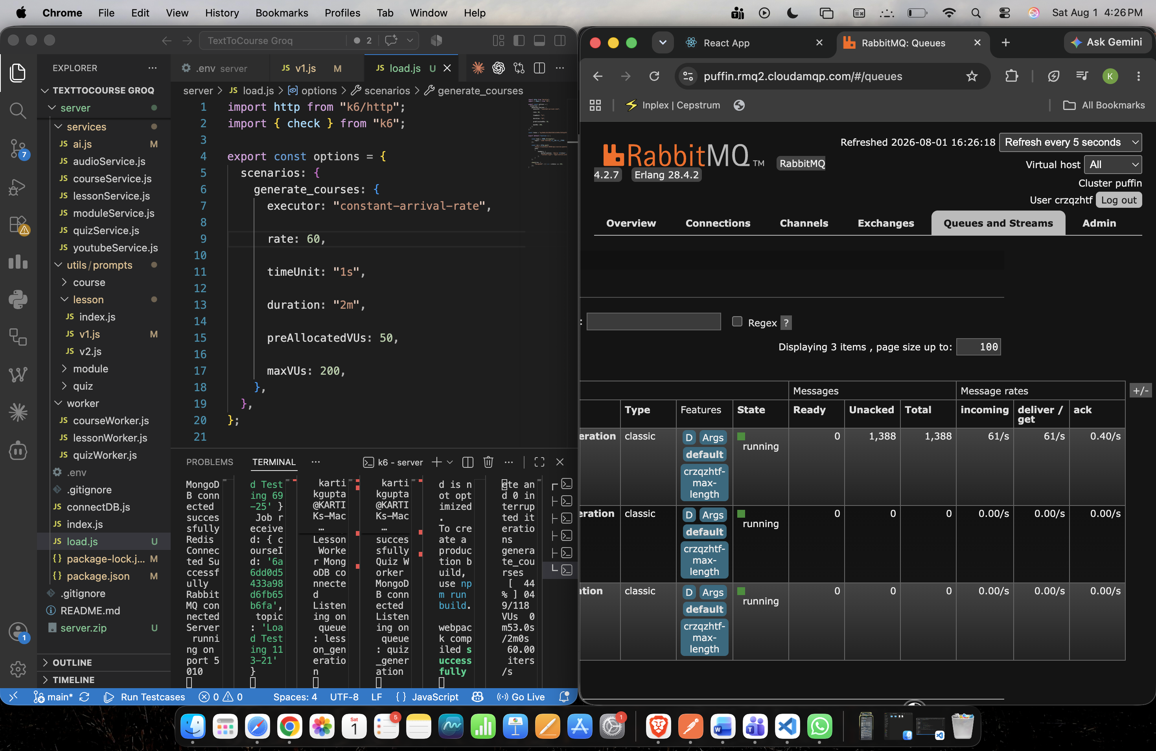

Load-tested the asynchronous API using k6. The service sustained approximately 59 requests/second (7,133 accepted requests over 2 minutes) with 0 HTTP failures. Stress testing identified the external LLM rate limit and queue backpressure as the primary scalability constraints, while the API layer remained responsive.
with rate 40/s below
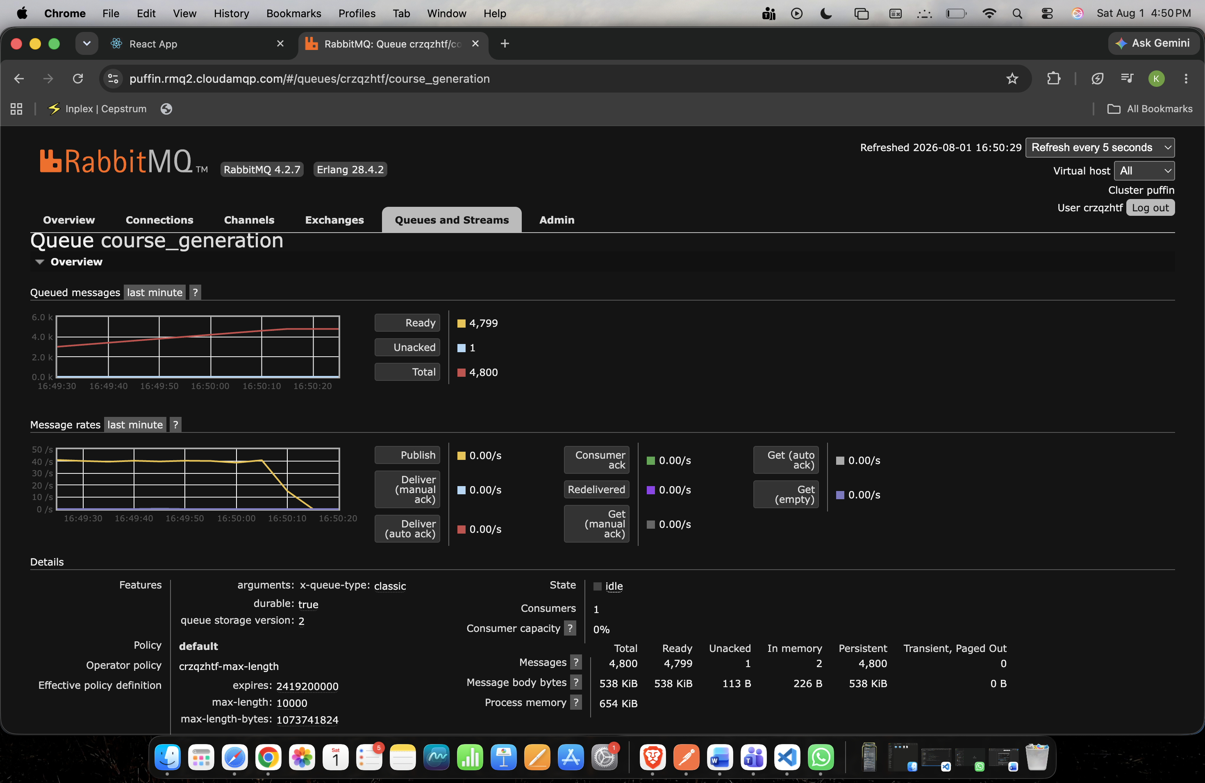
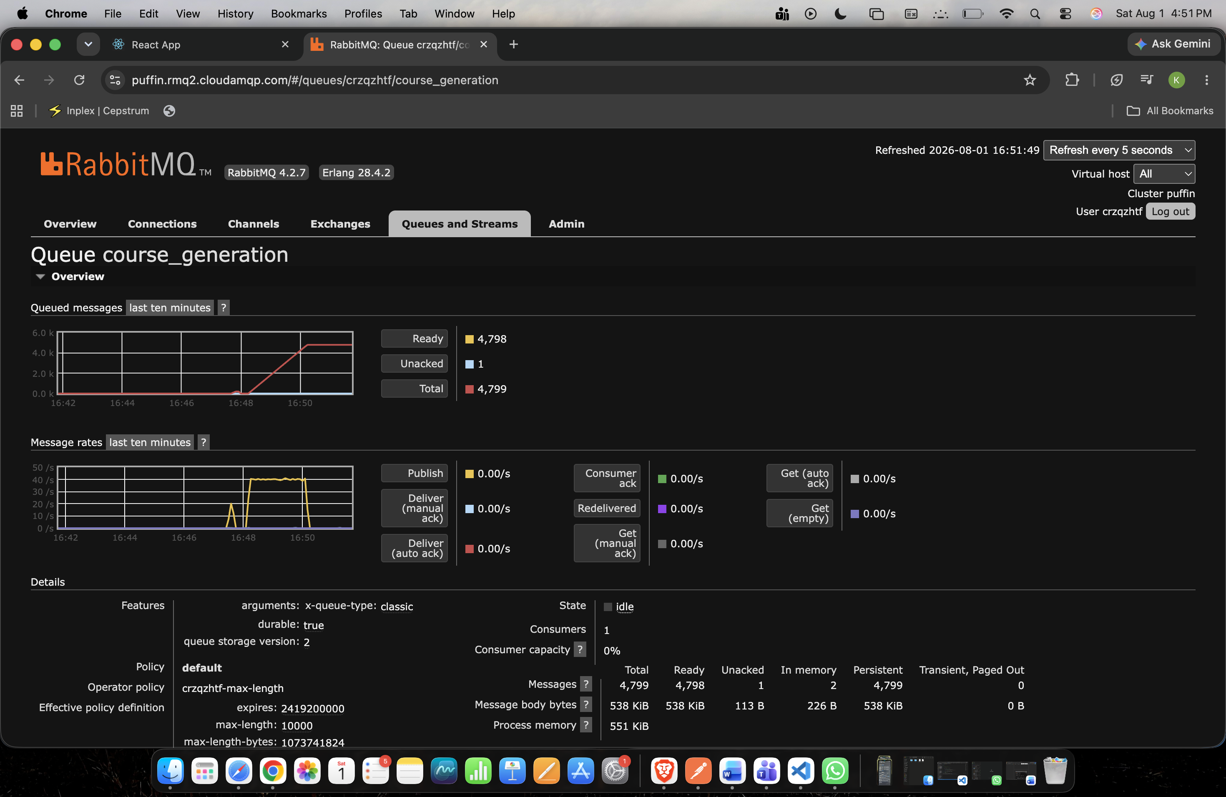

below is with rate 100/s
█ TOTAL RESULTS

checks_total.......: 12001 99.942834/s
checks_succeeded...: 100.00% 12001 out of 12001
checks_failed......: 0.00% 0 out of 12001

✓ Accepted

HTTP
http_req_duration..............: avg=73.76ms min=66.49ms med=71.7ms max=314.16ms p(90)=80.15ms p(95)=86.42ms
{ expected_response:true }...: avg=73.76ms min=66.49ms med=71.7ms max=314.16ms p(90)=80.15ms p(95)=86.42ms
http_req_failed................: 0.00% 0 out of 12001
http_reqs......................: 12001 99.942834/s

EXECUTION
iteration_duration.............: avg=73.98ms min=66.57ms med=71.93ms max=314.29ms p(90)=80.4ms p(95)=86.76ms
iterations.....................: 12001 99.942834/s
vus............................: 7 min=7 max=15
vus_max........................: 50 min=50 max=50

NETWORK
data_received..................: 4.8 MB 40 kB/s
data_sent......................: 12 MB 101 kB/s
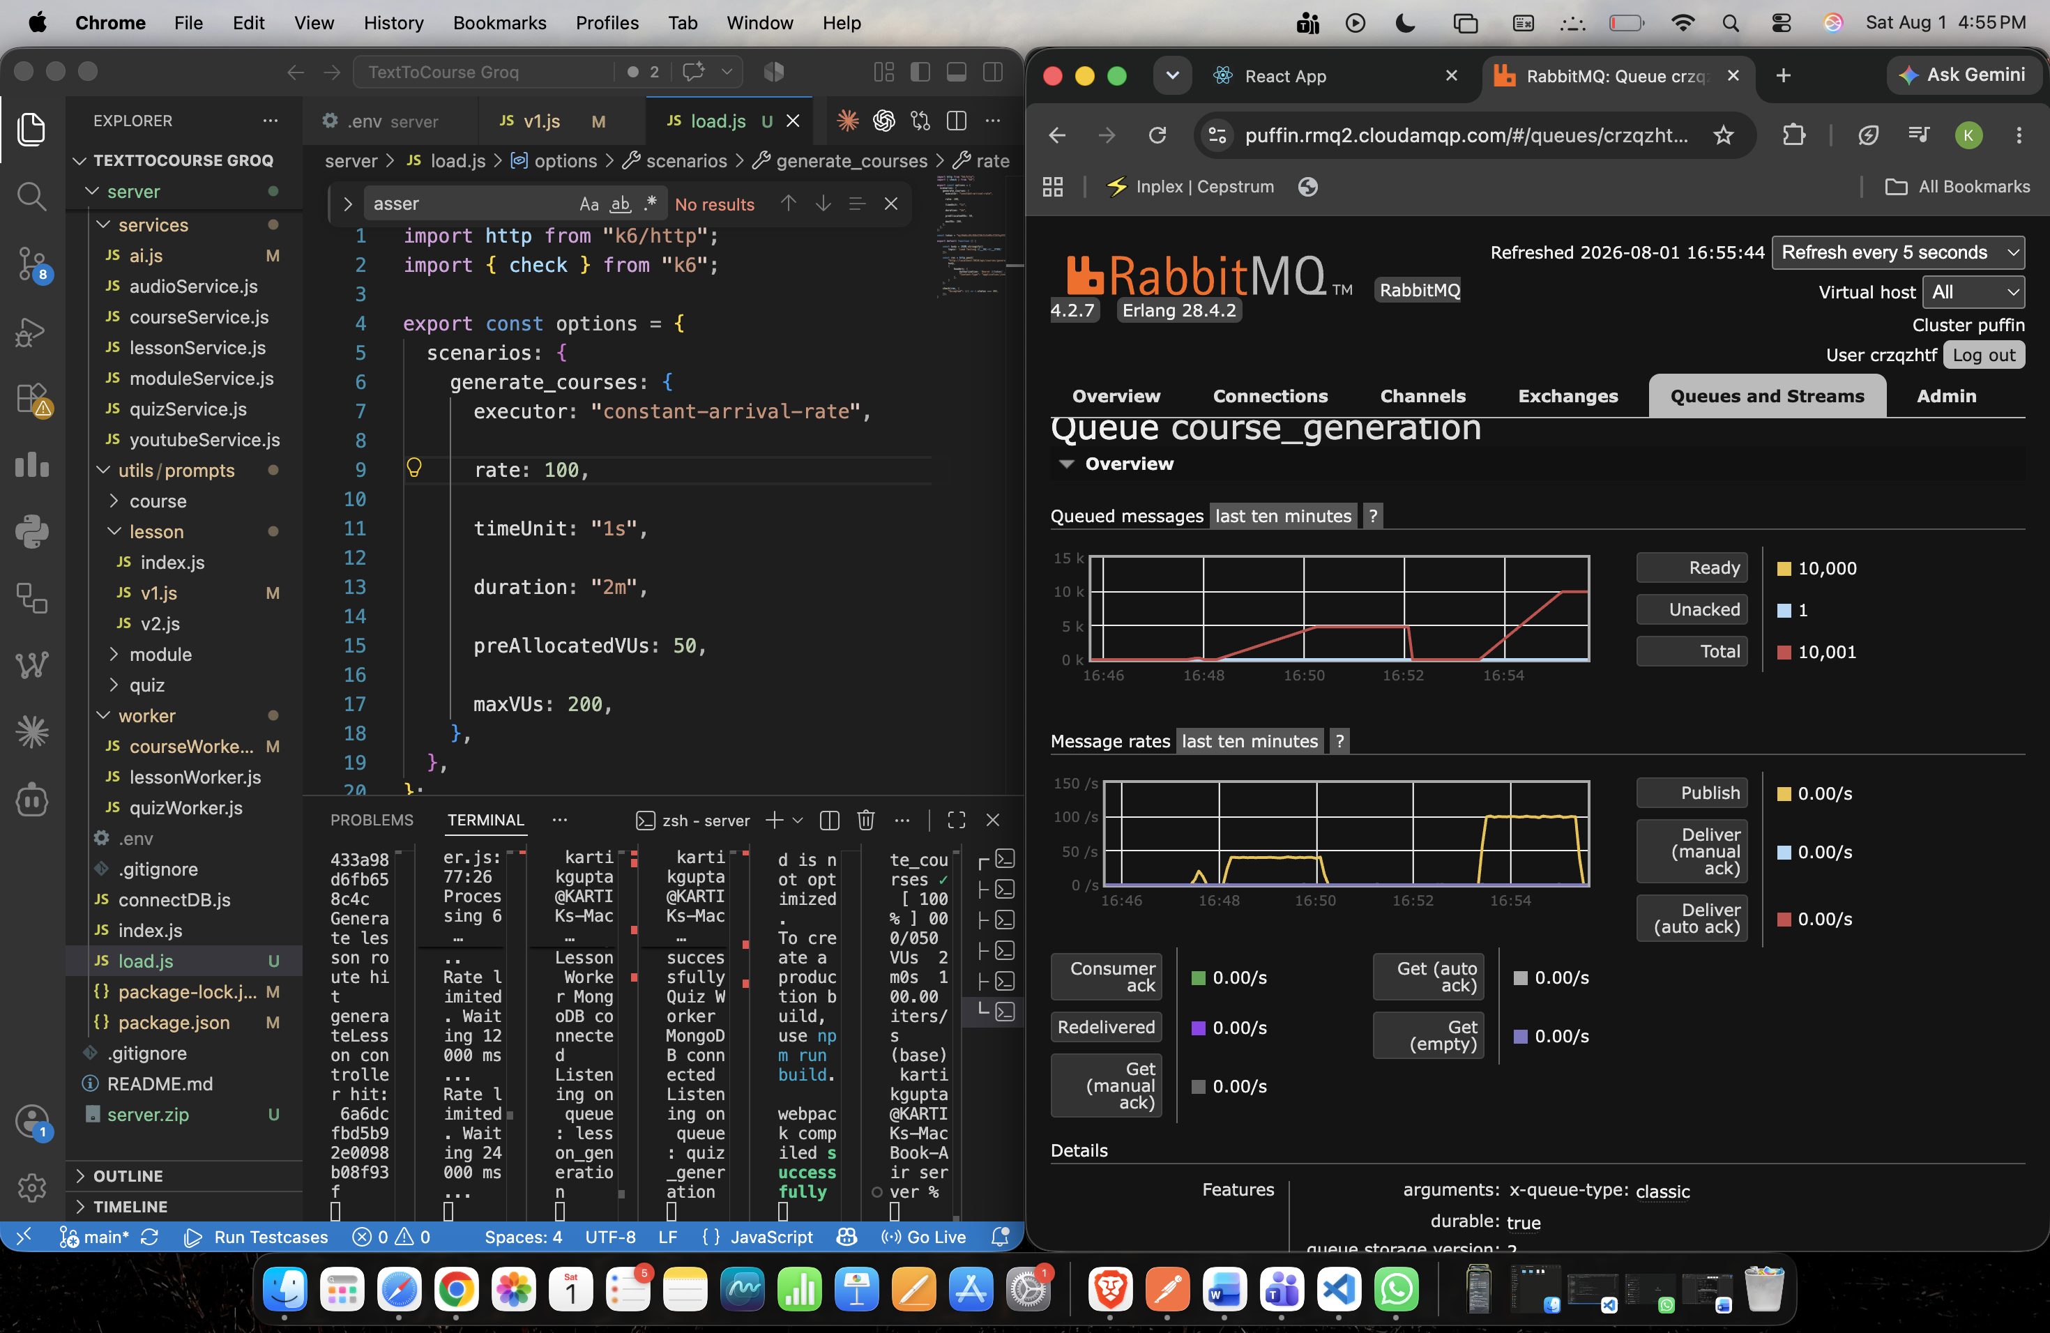

I tried with rate 1000/s, but could get till only 145.898975/s
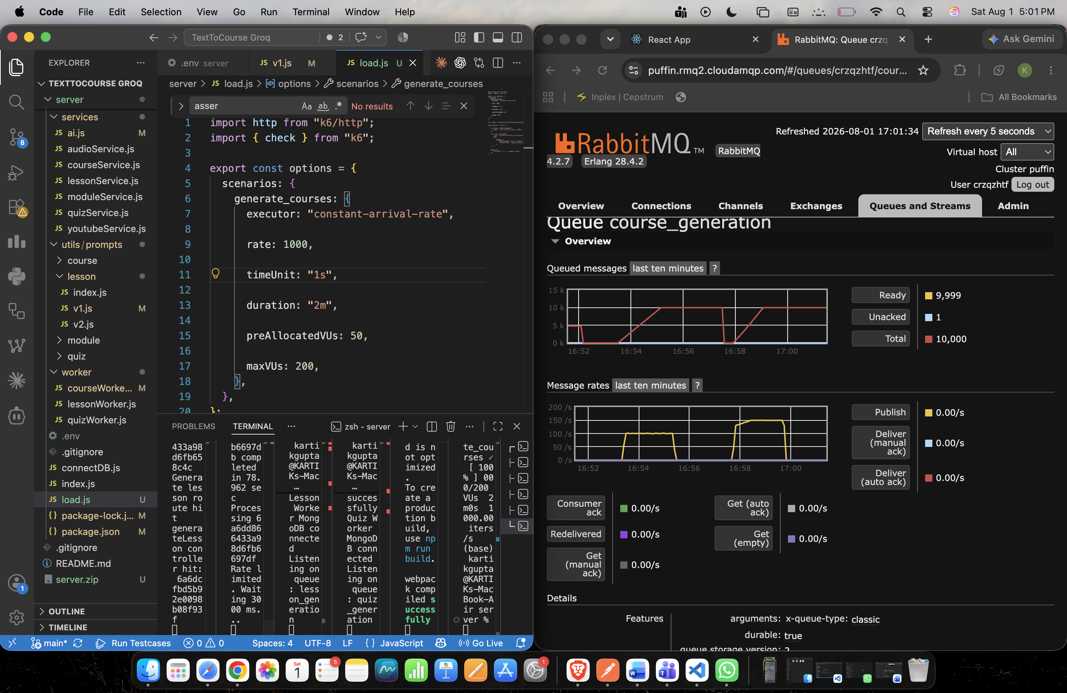
Macbook-Air server % k6 run load.js

checks_total.......: 17686 145.898975/s
checks_succeeded...: 100.00% 17686 out of 17686
checks_failed......: 0.00% 0 out of 17686

✓ Accepted

HTTP
http_req_duration..............: avg=1.33s min=63.32ms med=1.04s max=4s p(90)=1.92s p(95)=1.94s
{ expected_response:true }...: avg=1.33s min=63.32ms med=1.04s max=4s p(90)=1.92s p(95)=1.94s
http_req_failed................: 0.00% 0 out of 17686
http_reqs......................: 17686 145.898975/s

EXECUTION
dropped_iterations.............: 102315 844.037864/s
iteration_duration.............: avg=1.33s min=63.85ms med=1.04s max=4s p(90)=1.92s p(95)=1.94s
iterations.....................: 17686 145.898975/s
vus............................: 50 min=50 max=200
vus_max........................: 200 min=200 max=200

NETWORK
data_received..................: 7.0 MB 58 kB/s
data_sent......................: 18 MB 147 kB/s

I tried with rate 30/s, and got
█ TOTAL RESULTS

checks_total.......: 3601 29.991416/s
checks_succeeded...: 100.00% 3601 out of 3601
checks_failed......: 0.00% 0 out of 3601

✓ Accepted

HTTP
http_req_duration..............: avg=82.45ms min=60.53ms med=69.35ms max=1.66s p(90)=76.67ms p(95)=83.05ms
{ expected_response:true }...: avg=82.45ms min=60.53ms med=69.35ms max=1.66s p(90)=76.67ms p(95)=83.05ms
http_req_failed................: 0.00% 0 out of 3601
http_reqs......................: 3601 29.991416/s

EXECUTION
iteration_duration.............: avg=82.86ms min=60.64ms med=69.73ms max=1.66s p(90)=77.11ms p(95)=84.07ms
iterations.....................: 3601 29.991416/s
vus............................: 2 min=2 max=30
vus_max........................: 50 min=50 max=50

NETWORK
data_received..................: 1.4 MB 12 kB/s
data_sent......................: 3.6 MB 30 kB/s

Tool | Grafana k6

Duration | 2 min

Throughput | 30 req/s

Requests | 3,601

Success Rate | 100%

Avg Latency | 82 ms

P95 Latency | 83 ms
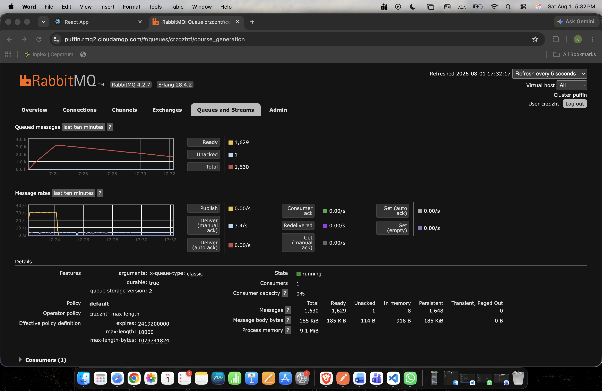

150 req/s

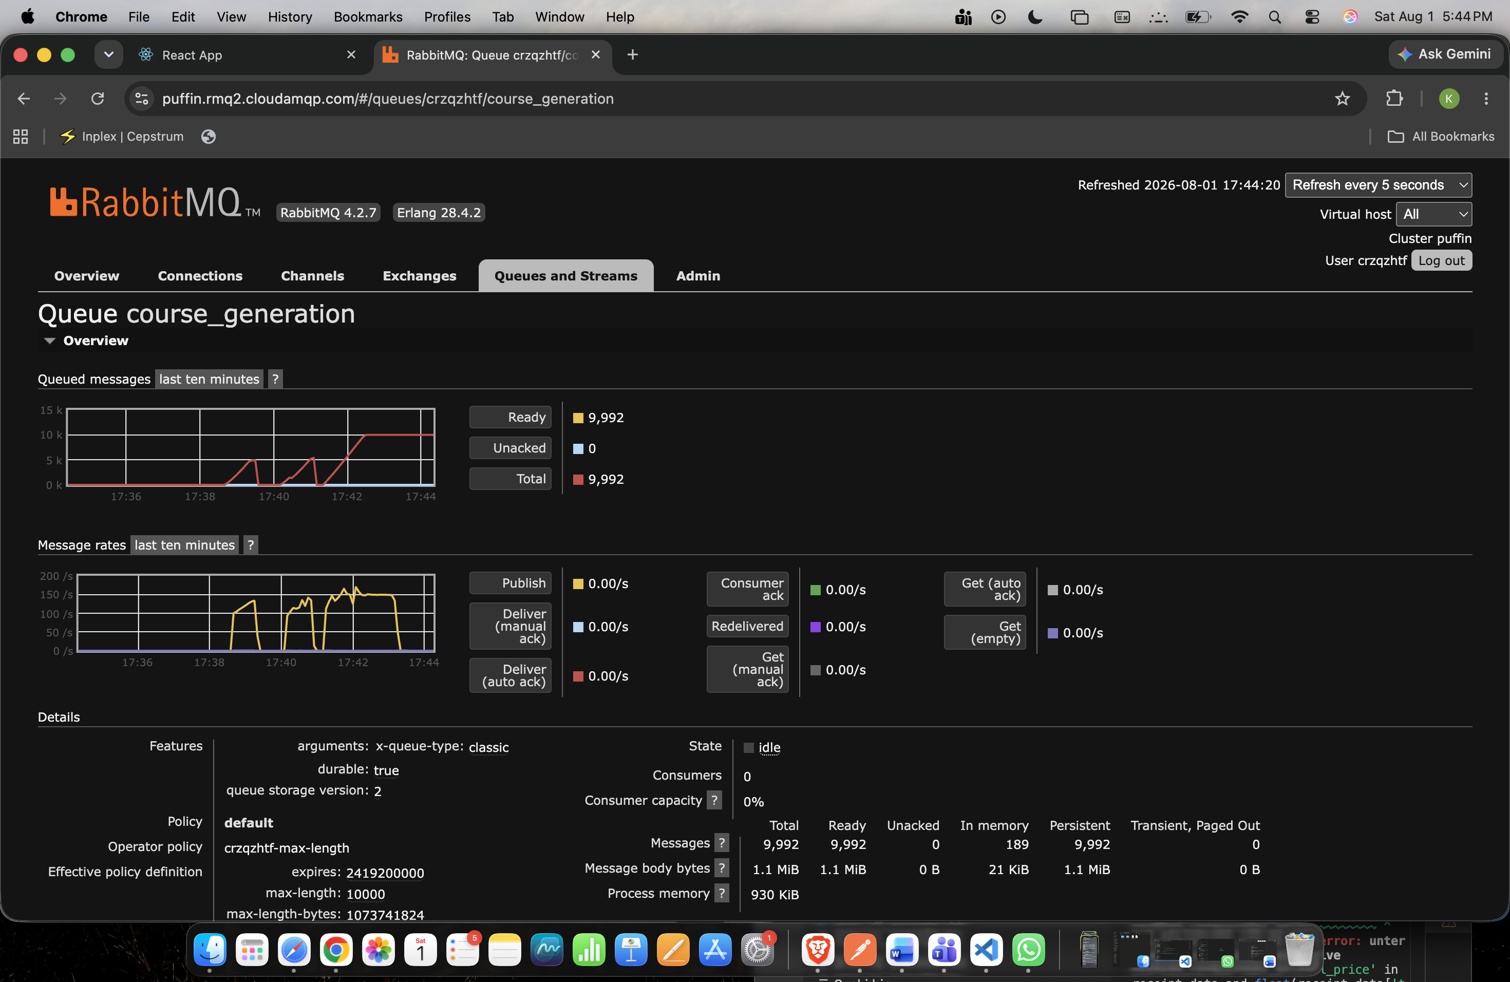

scenarios: (100.00%) 1 scenario, 200 max VUs, 2m30s max duration (incl. graceful stop):
* generate_courses: 150.00 iterations/s for 2m0s (maxVUs: 50-200, gracefulStop: 30s)

WARN[0046] Insufficient VUs, reached 200 active VUs and cannot initialize more executor=constant-arrival-rate scenario=generate_courses

█ TOTAL RESULTS

checks_total.......: 17785 146.706743/s
checks_succeeded...: 100.00% 17785 out of 17785
checks_failed......: 0.00% 0 out of 17785

✓ Accepted

HTTP
http_req_duration..............: avg=802.45ms min=59.31ms med=779.28ms max=3.53s p(90)=1.23s p(95)=1.31s
{ expected_response:true }...: avg=802.45ms min=59.31ms med=779.28ms max=3.53s p(90)=1.23s p(95)=1.31s
http_req_failed................: 0.00% 0 out of 17785
http_reqs......................: 17785 146.706743/s

EXECUTION
dropped_iterations.............: 216 1.781763/s
iteration_duration.............: avg=802.61ms min=59.37ms med=779.39ms max=3.53s p(90)=1.23s p(95)=1.31s
iterations.....................: 17785 146.706743/s
vus............................: 22 min=22 max=177
vus_max........................: 200 min=50 max=200

NETWORK
data_received..................: 7.1 MB 58 kB/s
data_sent......................: 18 MB 148 kB/s

Load-tested the asynchronous API using Grafana k6, sustaining ~100 requests/sec for 2 minutes (12,001 requests) with 100% request success, 74 ms average latency, and P95 latency below 87 ms. Stress testing beyond this point showed increasing latency and identified infrastructure/load-generation limits while the API continued to return successful responses for processed requests.
Increased Vus to max VU = 500, and 150req/s

running (2m01.2s), 000/200 VUs, 17785 complete and 0 interrupted iterations
generate_courses ✓ [ 100% ] 000/200 VUs 2m0s 150.00 iters/s
(base) kartikgupta@KARTIKs-MacBook-Air server % k6 run load.js

/\ Grafana /‾‾/
/\ / \ |\ __ / /
/ \/ \ | |/ / / ‾‾\
/ \ | ( | (‾) |
/ __________ \ |_|\_\ \_____/

execution: local
script: load.js
output: -

scenarios: (100.00%) 1 scenario, 500 max VUs, 2m30s max duration (incl. graceful stop):
* generate_courses: 150.00 iterations/s for 2m0s (maxVUs: 300-500, gracefulStop: 30s)

█ TOTAL RESULTS

checks_total.......: 17960 147.702226/s
checks_succeeded...: 100.00% 17960 out of 17960
checks_failed......: 0.00% 0 out of 17960

✓ Accepted

HTTP
http_req_duration..............: avg=1.56s min=528.86ms med=1.55s max=2.57s p(90)=1.99s p(95)=2.09s
{ expected_response:true }...: avg=1.56s min=528.86ms med=1.55s max=2.57s p(90)=1.99s p(95)=2.09s
147.7022226/s
bullets in resume:
1. Load-tested asynchronous backend using Grafana k6, sustaining ~100 requests/sec (12k+ requests over 2 minutes) with 100% request success and 74 ms average latency.
2. Stress-tested to ~148 requests/sec to identify scalability limits, demonstrating analysis of bottlenecks (LLM quotas, queue backpressure, and backend resource saturation).

